# ***Ahsanullah University of Science & Technology***

Department of Computer Science & Engineering



Hotel Management System

**CSE 3224**

**Information System Design & Software Engineering Lab**

Submitted By:

Md Junaeid Bhuiyan 16.01.04.055

Afranul Haque Afran 16.01.04.059

Nazmus Sakib 16.01.04.072

Md Ruhul Amin Rakib 16.01.04.074

**Sampling Decisions:**

We have undertaken target-oriented method for sampling. Our target research included Facebook, Direct E-mail, messages, and universities in Dhaka city.

**Sample Design:**

**1. Sample Size:** The sample size selected for the research is 40. **2. Parameters of Interests:** The major parameter of interest is the subgroup of people who understand management-based application.

**Data Collection Tool Used:**

The data collection tool used for the research is “Questionnaires” to get the primary data for the empirical research on customer preference on augmented furnishing application.

The Questionnaire which is attached below.

**Questionnaire on Hotel Management System**

(We would like to know more about how you use augmented reality furnishing app in real life.it will help us to improve our application more user friendly)

1. (Personal Information)

Name: ________________________________________

Address: ________________________________________

________________________________________

________________________________________

E-mail Id: _______________________________________

1. (Demographics Information)

a) Gender

* Female
* Male

b) Age-Group

* Below 20
* 20-29
* 30-39
* Above 50

c)Occupation:

* Receptionist
* Manager
* Hotel employee

1. Project Related Questions

a) What will be better for managing a hotel’s informations?

* Analog process (such as register khata)
* Modern Digital Process(such as digital computer system)

b) Have you ever faced troubles in analog system ?

* Yes
* No

c) What kinds of problems have you faced in analog system ?

* Managing data
* Data duplicity
* Losing Data
* Time Consuming
* Delay in Taking Orders
* Security Issues
* Others

d) Do you think it is important to digitalize the analog system?

* Not so important
* Important
* Very important

e) Reasons for replacing the current analog system?

* Needs Update
* Improving Efficiency
* Technical Issues
* Missing Features
* Bad Interface
* Growth Of Business

f) Have you ever used a computerized system to manage your hotel?

* Yes
* No

g) Which features you want in your system from below?

* Reservation Capabilities
* Guest Management
* Housekeeping Service
* Facilities Maintenance
* Restaurant Integration

h) What kind of information would you like to take from a customer?

* Name
* Address
* NID
* Age
* Contact info
* E mail
* Martial status

i) Do you want multiple language in your system?

* Yes
* no

j) Do you prefer separate accounts and authorized access for every employee?

* Yes
* no

k) Do you prefer staff information onto the system?

* Yes
* No

l) What categories of room you prefer in this system?

* VIP, Regular, Economic
* Premium(AC), Normal(AC),Normal(Non-AC), Economic

m) Would you prefer room pictures in your system?

* Yes
* No

think of a furniture augmented reality based app?

|  |  |  |  |
| --- | --- | --- | --- |
| **Features** | **Important** | **Less important** | **Very important** |
| User friendly design |  |  |  |
| 3d view of every furniture |  |  |  |
| Pay money after going outlet |  |  |  |
| Outlet Address |  |  |  |
| Seller's contact no |  |  |  |
| Offers and discounts info |  |  |  |

n) Would you like to prefer discount system in your application ?

* Yes
* No

o) Which types of customers visit in your hotel ?

* Regular
* Non regular
* Traveler
* Sessional
* Foreigner

p) How many visitors come to your hotel per day on average?

* 20-50
* 50-100
* 100-200
* More
* Less

q) 18.Is there any food order system in your hotel?

* Yes
* No

q) Would you prefer separate food menu system for separate day-hour and also with their pictures?

* Yes
* No

r) In which way you prefer the payment system should be?

* Taking cash
* Online payment
* Taking cards
* Others

t) When using our system, as a user what affects your satisfaction the most?

|  |  |  |  |
| --- | --- | --- | --- |
| **Features** | **Less Important** | **Important** | **Very important** |
| User Interface |  |  |  |
| Easy to Use |  |  |  |
| Authorized access |  |  |  |
| Available information |  |  |  |
| User Privacy |  |  |  |

S) Managing the system what importance these features will make?

|  |  |  |  |
| --- | --- | --- | --- |
| **Features** | **Less Important** | **Important** | **Very important** |
| Online Payment |  |  |  |
| Reminder Message |  |  |  |
| Rooms Pictures |  |  |  |
| Different Food Menu System |  |  |  |
| Discount System |  |  |  |

**Data Analysis:**

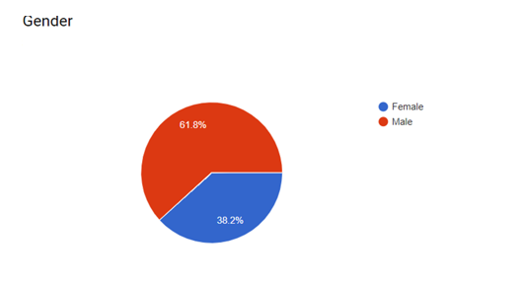

|  |  |
| --- | --- |
| **Gender** | |
| Female  38.2% | Male  61.8% |

**Illustration:**

The above diagram depicts that out of the total 34 respondent 61.8% were male as the objective was to study the user behavior,as hotel management system app is more used by male respondent.

**Age:**

|  |  |  |
| --- | --- | --- |
| **Age** | | |
| 20-25  79.5% | 25-30  15.4% | 30-40  5.1% |

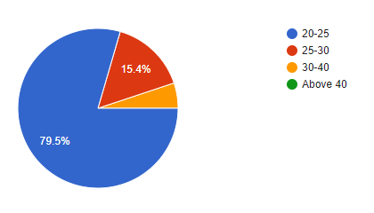

**Illustration:**

* The 79% of the respondent were 20-25.This section is more stronger.
* Another 15.1% of the respondent were ranging from 25-30 age and the remaining 6.1 % were respondent were 30-40 age.

|  |  |  |
| --- | --- | --- |
| **Residence** | | |
| DHAKA  76.9% | Rajshahi  12.8% | Others  10.6% |

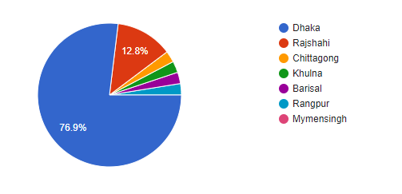

**Illustration:**

* The 76.9% of the respondent live in Dhaka and the remaining 12.8% of them live in gazipur and the other 10.6% live in other district. So, it is clear that most of the users lives in Dhaka.

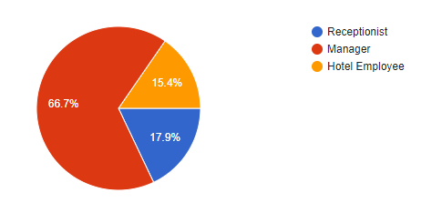

|  |  |  |
| --- | --- | --- |
| **Occupation** | | |
| Receptionist  17.9% | Manger  66.7% | Hotel Employee  15.4% |

**Q** .  What will be better for managing a hotel's informations?

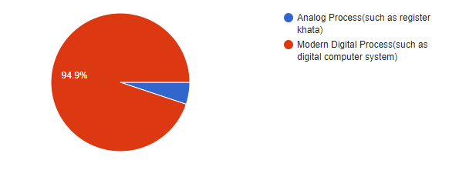

**Illustration :**

* The 94.9% of the respondent for modern and the remaining others wants analog process .

So, it is clear that most of the employees want modern digital process.

**Q.** Have you ever faced troubles in analog system ?

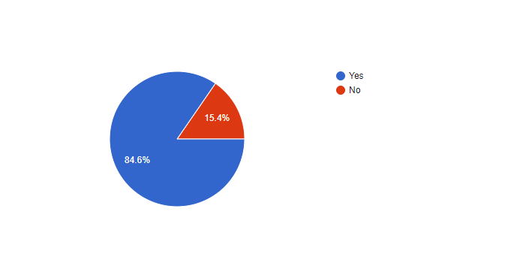

Illustration-

* The 84.6% of the respondent face trouble in analog process. So, it is clear that most of the employees want an update.

**Q.** What kinds of problems have you faced in analog system?

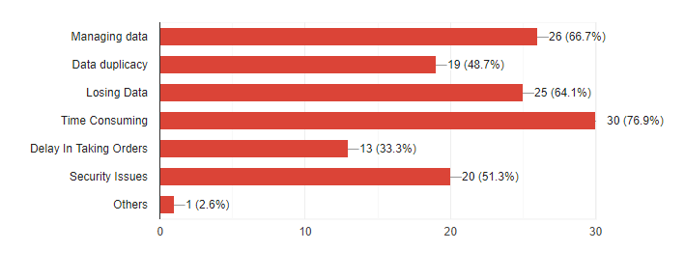

Illustration-

* According to the chart , Time consuming is one of the most problematic issues and the percentage is about 76.9%.
* Other great problems are to manage data, loose data , security issues and data duplicacy.

**Q.** Do you think it is important to digitalize the analog system?

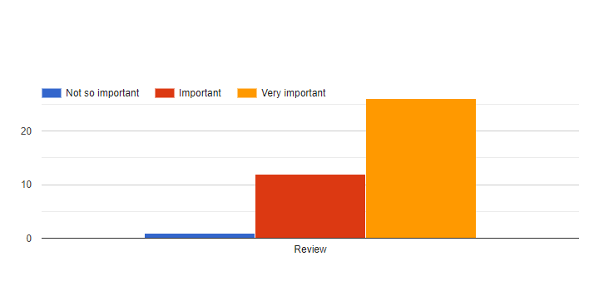

Illustration-

* Maximum of the respondent feels it is very important to digitalize this process.

**Q.** Reasons for replacing the current analog system: -

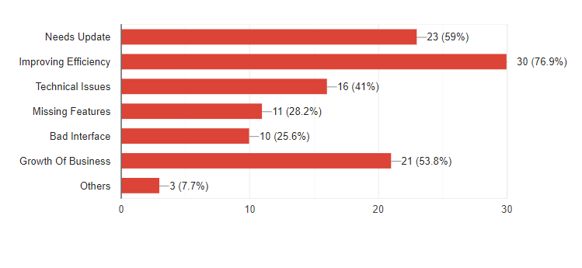

Illustration-

* Improving efficiency is the most logical reasons according to the respondents, and percentage is about 76%
* The other vital reasons are respectively needing update, growth of business, technical issues and so on.

**Q.** Have you ever used a computerized system to manage your hotel?

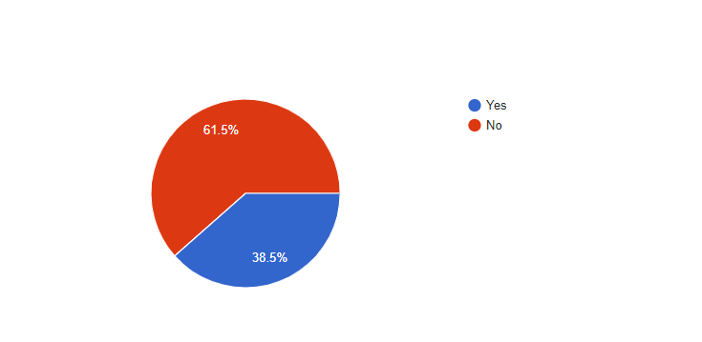

**Illustration-**

* According to the chart, about 61.5% respondents have never used a computerized system and rest of the respondents are introduced with digital system.

**Q**. Which features you want in your system from below?

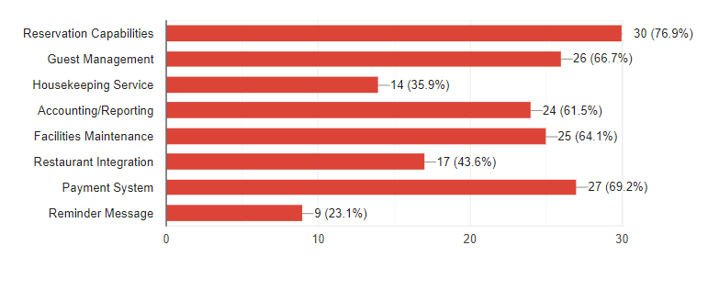

Illustration-

* Most of the respondents want to add reservation capabilities, payment procedure, guest management in their system.
* Some of the respondents want to add facilities maintenance, accounting/reporting, reminder message to enrich their systems.

**Q.** What kind of information would you like to take from a customer?

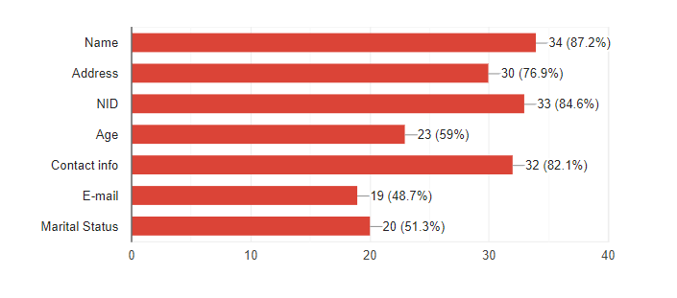

**Illustration-**

* About 80%+ respondents want to keep some essential information’s like name, nid , contact info . The other necessary parts are address, age, email and marital status.

**Q.** Do you want multiple language in your system?

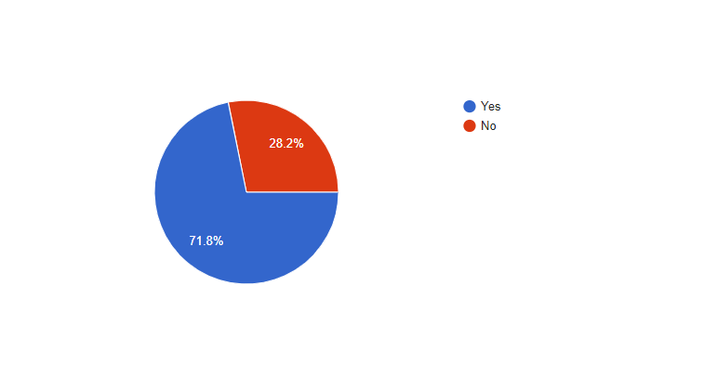

**Illustration-**

* According to the chart, about 71% respondents prefer multiple language in their system. So this system will be featured in multiple language.

**Q.** Do you prefer separate accounts and authorized access for every employee?

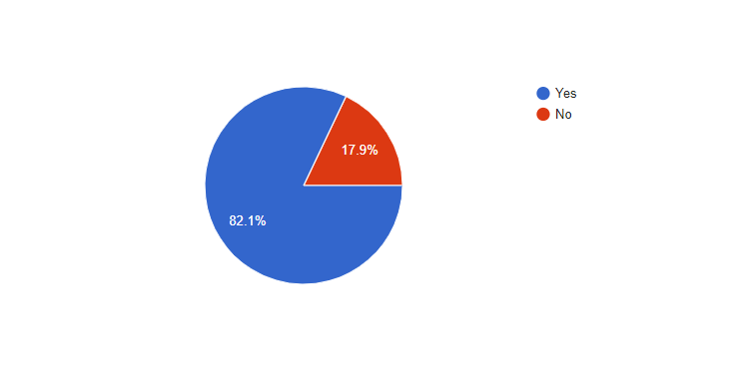

**Illustration-**

* According to the respondents, about 82% respondents prefer separate accounts and authorized access for every employee.

**Q.** Do you prefer staff information onto the system?

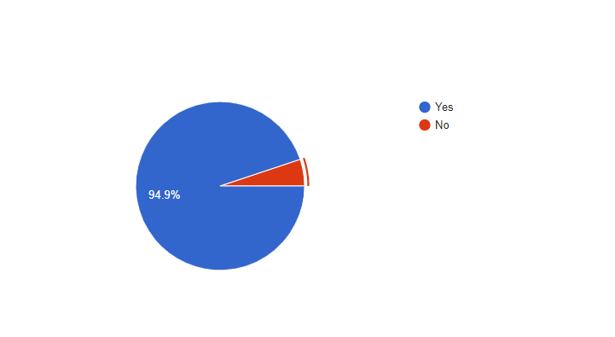

**Illustration-**

* To maintain the system fairly, most of the respondents, about 95%, prefer to keep staff information onto the system.

**Q.** Would you prefer room pictures in your system?

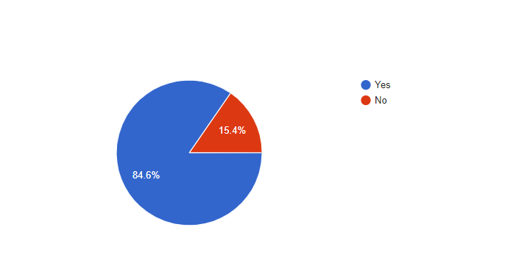

**Illustration-**

* According to the chart, about 85% of the respondents prefer to add room pictures in their system so that customer can select better one easily.

**Q.** Would you like to prefer discount system in your application?

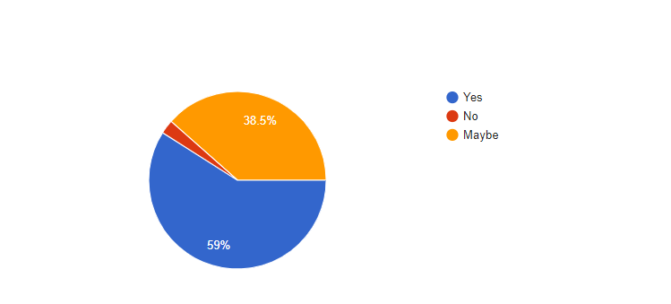

**Illustration-**

* Most of the respondents prefer discount system in their application to interact their customer.

**Q.**  The discount margin should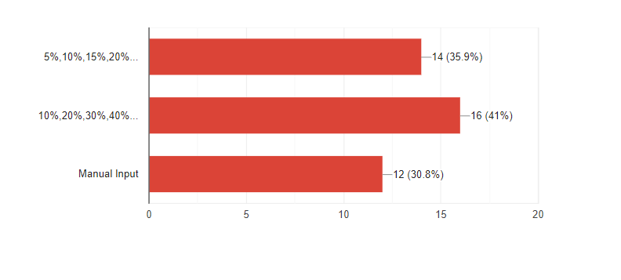

**Illustration-**

* About 41% respondents want to define an attractive discount to hold customer. Mainly discount can be varied to season.

**Q.**  How many visitors come to your hotel per day on average?

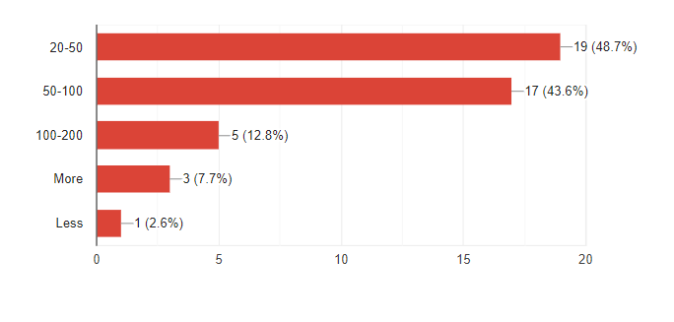

**Illustration-**

* According to the opinion of 49% respondents, about 20-50 visitors come to their hotel per day on average. It can be varied due to environmental structures of their hotel.

**Q.**  Is there any food order system in your hotel?

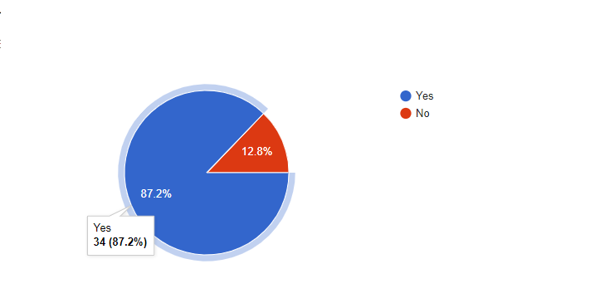

**Illustration-**

* According to the information of respondents, most of the hotel provides food to their customers in exchange of money.

**Q.** Would you prefer separate food menu system for separate day-hour and also with their pictures?

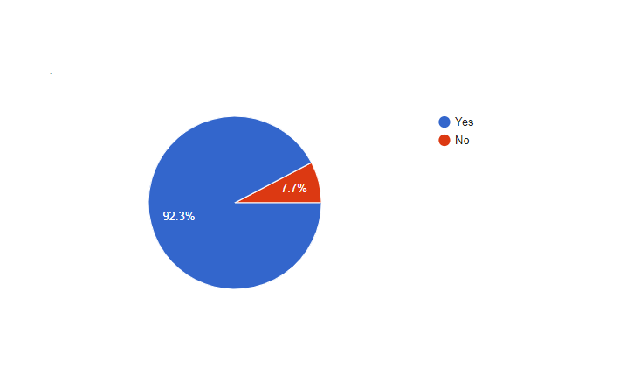

**Illustration-**

* According to the chart , about 92% of the respondents prefer separate food menu system for separate day hour and also with their pictures.

**Q.** What will be the minimum time to book a room for a customer?

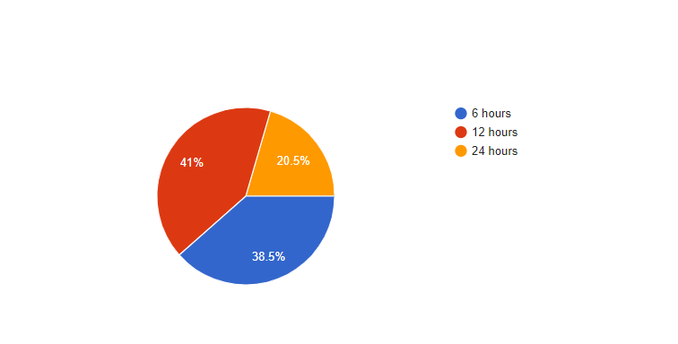

**Illustration-**

* About 41% of the respondents think, most of the administrators of hotels give a minimum time, about 12 hours, to a customer. But it can be varied from hotel to hotel.

**Q.** In which way you prefer the payment system should be?

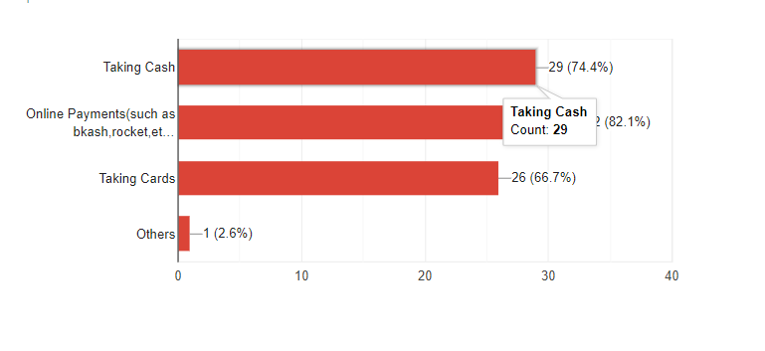

**Illustration-**

* Online payment is getting more popular day by day. So most of the respondents prefer online payments beside taking cash. They also prefer the payment should be done through taking cards or others way.

**Q.** When using our system, as a user what affects your satisfaction the most?

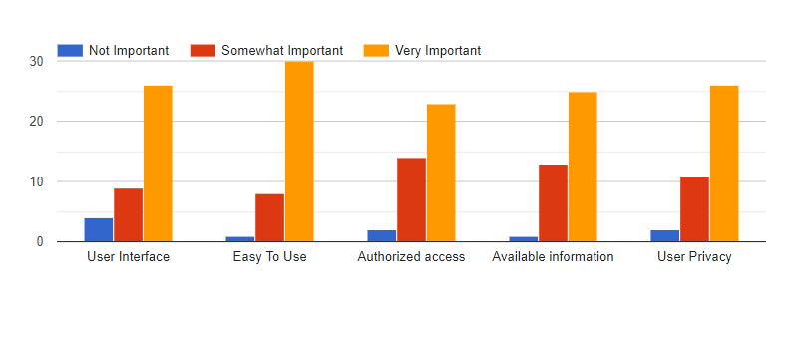

**Illustration-**

* User interface is one of the most important parts of developing a system based application. In this aspect , most of the respondents review it as very important and some of them think it as somewhat important.
* The article “Easy to Use” is one of the most vital parts of developing a system based application. In this aspect , most of the respondents review it as very important and few of them think it as somewhat important.
* Authorized access is more important to maintain a system carefully. About 20+ respondents out of 30 think it as very important and some of them think it as somewhat Important.
* It is essential to have available information including related persons or activities or schedule in a system . Like other parts, according to the respondents , it is very important or somewhat important.
* It is essential to ensure user privacy of a system. Mainly it is a part of security of a system . . In this aspect , most of the respondents review it as very important and some of them think it as somewhat important.

**Q.** Managing the system what importance these features will make?

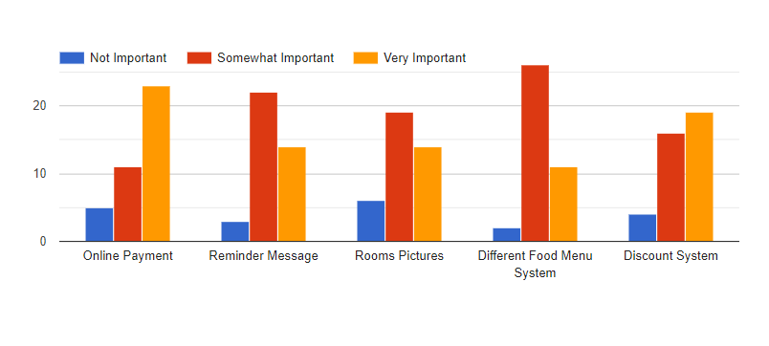

**Illustration-**

* Online payment is more important now a days. In this chart, most of the respondents are interested in keeping online payment and think it as very important . So we will take the best one.
* Reminder message reminds the receptionists of a customer’s deadline. Here it is a somewhat important part according to the respondents.
* Adding room pictures in this system is somewhat important according to the respondents of our survey. Some of them think it as very important too.
* Keeping different food menu is also a somewhat important part. But some think it as very important .
* Discount system can play a good role in a hotel management system. Mainy to attract a customer , administrator can keep discount policy. So in this chart, a number of respondents think it as very important and some think it as somewhat important.